Ex. No. : | 08
Register No. : | 240701491 | Name : P Sharweshvar
1

Deluge Scripting in Zoho Creator

Aim
To learn the Deluge scripting language of Zoho Creator by writing and running ten standard stand-alone programs that use variables, conditions, loops, lists, maps, string functions and date functions.

Introduction
  - Deluge
Deluge (Data Enriched Language for the Universal Expression) is the scripting language built into Zoho Creator. It adds logic to an application without a separate programming environment. A Deluge script is written in the script editor of a workflow, a function, a button, a schedule or an approval. The result of a script can be shown with the info statement, which is useful while learning and testing.
  - Where Deluge Scripts Are Used
Table 2 lists the places in a Zoho Creator application where Deluge scripts run. The ten programs of this experiment are stand-alone programs that need no form or other setup and can be used in any of these places.

Objectives of the Study
- To declare variables and use arithmetic operators and the basic data types of Deluge.
- To control the flow of a script with if / else conditions and for each loops.
- To store data in lists and maps and to process text and dates with built-in functions.
- To solve common problems such as finding the largest number, counting even and odd numbers and calculating a factorial.

Procedure
- Open Zoho Creator and open a practice application in Edit mode, then click Workflow in the top bar.
- Open the Functions section and click + New Function to create a standalone function for each program, for example program_01_variables.
- Type or paste the Deluge script of the program in the script editor.
- Click Save, then click Execute (Run) to run the function.
- Read the output of the info statements in the output window of the editor.
- Take a screenshot of the editor with the output for every program.

Dept. of Computer Science and Engineering | Rajalakshmi Engineering College

Detailed Analysis
Table 1 lists the ten programs and the Deluge features used by each.

No. | Program | Deluge features used
1 | Variables and arithmetic operators | Variables, arithmetic, %
2 | if / else if condition | if, else if, else
3 | for each loop: sum and average | List, for each, size
4 | List operations | add, get, contains, sort, removeElement
5 | Map operations | Map, put, get, containKey, remove, keys
6 | String functions | length, toUpperCase, subString, indexOf, replaceAll, toList
7 | Date functions | zoho.currentdate, addDay, addMonth, toString
8 | Largest and smallest in a list | List, for each, if, comparison
9 | Counting even and odd numbers | for each, if / else, % operator
10 | Multiplication table and factorial | for each, info, multiplication
Table 1: Deluge programs written in this experiment
Table 2 shows where Deluge scripts are used in a Zoho Creator application.

Place | Use of the Deluge script
Form workflow | Fills fields, validates data and updates other records when a record is created or edited
Button | Runs a script when the user clicks a button on a form, report or page
Function | A reusable script that is called from workflows, buttons and schedules
Schedule | Runs a script at a fixed date and time
Approval | Runs a script when a record is approved or rejected
Blueprint | Runs a script when a record moves from one stage to the next
Table 2: Places where Deluge scripts are used
The ten programs follow, each with its script and the output it gives.

Deluge script | Sample output
price = 250;  quantity = 4;  discount = 10;  subtotal = price * quantity; discountAmt = subtotal * discount / 100; total = subtotal - discountAmt;  info "Subtotal : " + subtotal; info "Discount : " + discountAmt; info "Total : " + total;  info "Remainder : " + (subtotal % 3); | Subtotal : 1000  Discount : 100.0  Total : 900.0  Remainder : 1
Program 1: Variables and arithmetic operators

2 Dept. of Computer Science and Engineering | Rajalakshmi Engineering College

Deluge script | Sample output
marks = 72;  if(marks >= 90)  {  grade = "A+";  }  else if(marks >= 75)  {  grade = "A";  }  else if(marks >= 60)  {  grade = "B";  }  else  {  grade = "C";  }  info "Marks : " + marks; info "Grade : " + grade; | Marks : 72 Grade : B
Program 2: if / else if condition

Deluge script | Sample output
marks = List(); marks.add(78); marks.add(85); marks.add(92); marks.add(66); sum = 0;  for each m in marks  {  sum = sum + m;  }  average = sum / marks.size(); info "Sum : " + sum; info "Average : " + average; | Sum : 321  Average : 80.25
Program 3: for each loop: sum and average

Deluge script | Sample output
names = List(); names.add("Ravi");  names.add("Anita");  names.add("Meena");  info "Size : " + names.size(); info "Second : " + names.get(1);  info "Has Anita : " + names.contains("Anita"); info "Sorted : " + names.sort(true); names.removeElement("Ravi");  info "After remove : " + names; | Size : 3 Second : Anita  Has Anita : true  Sorted : [Anita, Meena, Ravi] After remove : [Anita, Meena]
Program 4: List operations

Deluge script | Sample output
student = Map(); student.put("Name", "Anita");  student.put("Dept", "CSE"); student.put("Marks", 88); info student.get("Name");  info student.containKey("Dept"); student.remove("Dept");  info student.keys(); info student.size(); | Anita true  [Name, Marks] 2
Program 5: Map operations

3 Dept. of Computer Science and Engineering | Rajalakshmi Engineering College

Deluge script | Sample output
text = "Zoho Creator Lab"; info text.length();  info text.toUpperCase(); info text.toLowerCase(); info text.subString(5, 12); info text.indexOf("Creator");  info text.replaceAll("Lab", "Record"); info text.contains("Zoho");  words = text.toList(" "); info words.size(); | 16  ZOHO CREATOR LAB  zoho creator lab Creator  5  Zoho Creator Record true  3
Program 6: String functions

Deluge script | Sample output
today = zoho.currentdate; info "Today : " + today;  info "Next week : " + today.addDay(7); info "Next month : " + today.addMonth(1);  info "Day name : " + today.toString("EEEE");  info "Formatted : " + today.toString("dd/MM/yyyy"); info "Year : " + today.getYear(); | Today : 18-Oct-2026 Next week : 25-Oct-2026 Next month : 18-Nov-2026 Day name : Sunday Formatted : 18/10/2026 Year : 2026
Program 7: Date functions

Deluge script | Sample output
nums = List(); nums.add(45);  nums.add(12);  nums.add(78);  nums.add(33);  largest = nums.get(0); smallest = nums.get(0); for each n in nums  {  if(n > largest)  {  largest = n;  }  if(n < smallest)  {  smallest = n;  }  }  info "Largest : " + largest; info "Smallest : " + smallest; | Largest : 78  Smallest : 12
Program 8: Largest and smallest in a list

4 Dept. of Computer Science and Engineering | Rajalakshmi Engineering College

Deluge script | Sample output
nums = List(); nums.add(3);  nums.add(8);  nums.add(15);  nums.add(20);  nums.add(7); evenCount = 0;  oddCount = 0;  for each n in nums  {  if(n % 2 == 0)  {  evenCount = evenCount + 1;  }  else  {  oddCount = oddCount + 1;  }  }  info "Even numbers : " + evenCount; info "Odd numbers : " + oddCount; | Even numbers : 2 Odd numbers : 3
Program 9: Counting even and odd numbers

Deluge script | Sample output
nums = List(); nums.add(1);  nums.add(2);  nums.add(3);  nums.add(4);  nums.add(5); fact = 1;  for each n in nums  {  fact = fact * n;  info "3 x " + n + " = " + (3 * n);  }  info "Factorial of 5 : " + fact; | 3 x 1 = 3  3 x 2 = 6  3 x 3 = 9  3 x 4 = 12  3 x 5 = 15  Factorial of 5 : 120
Program 10: Multiplication table and factorial

Output
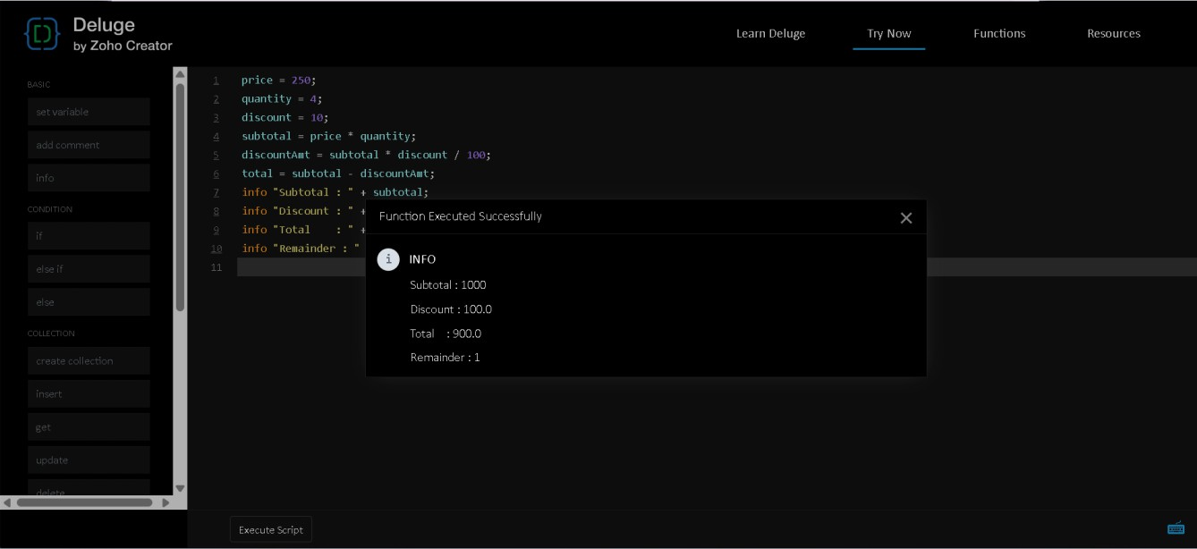
Figure 1: Program 1 (Variables and arithmetic operators) and its output

5 Dept. of Computer Science and Engineering | Rajalakshmi Engineering College

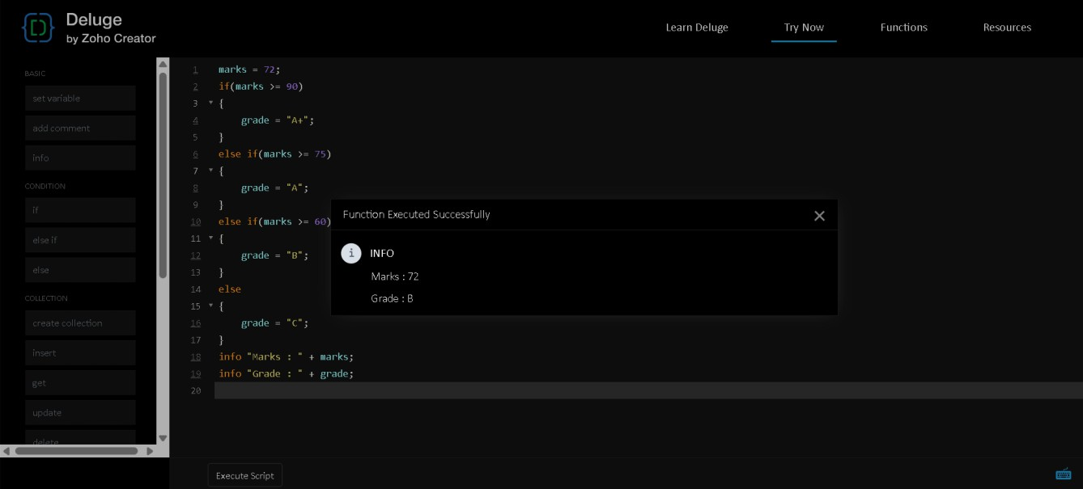
6
Figure 2: Program 2 (if / else if condition) and its output
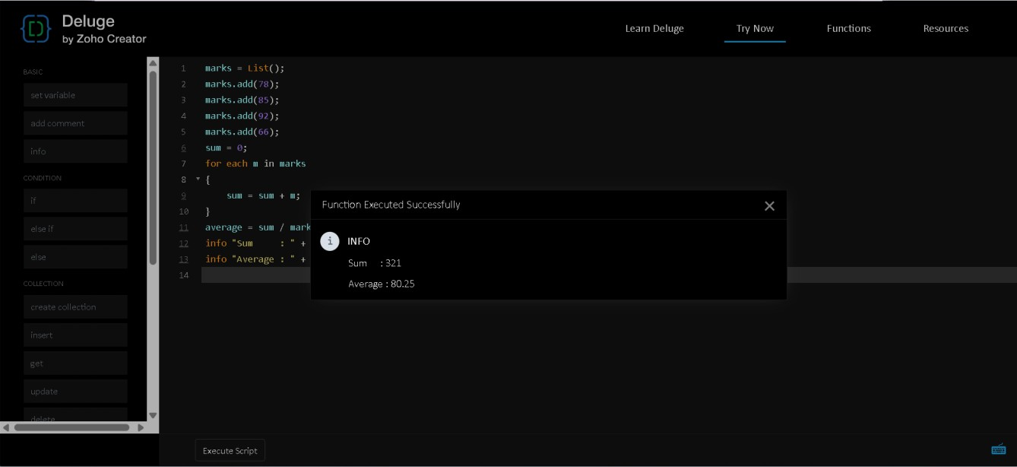
Figure 3: Program 3 (for each loop: sum and average) and its output

Dept. of Computer Science and Engineering | Rajalakshmi Engineering College

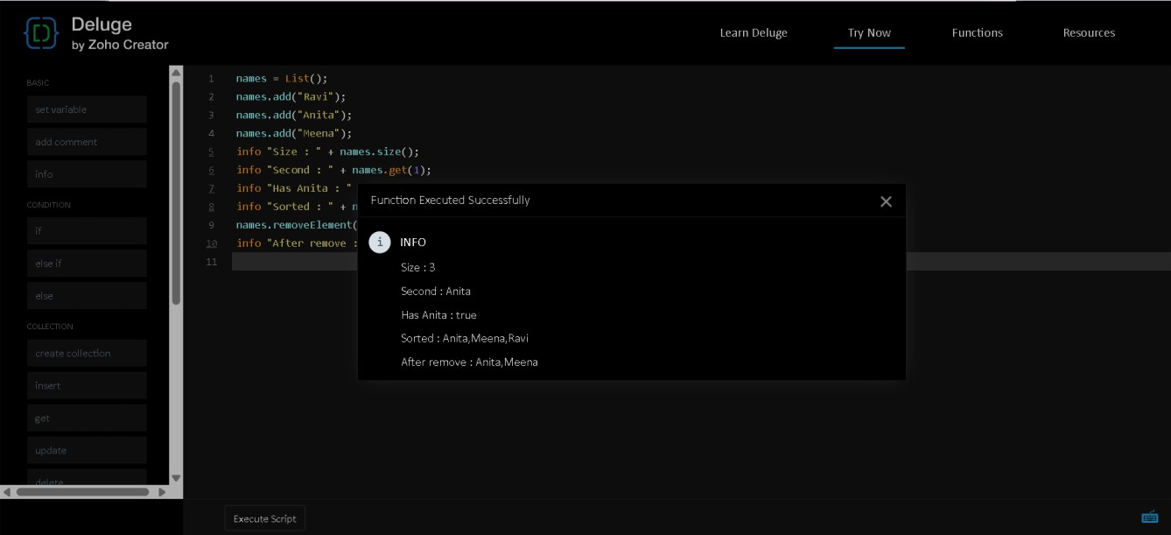
7
Figure 4: Program 4 (List operations) and its output
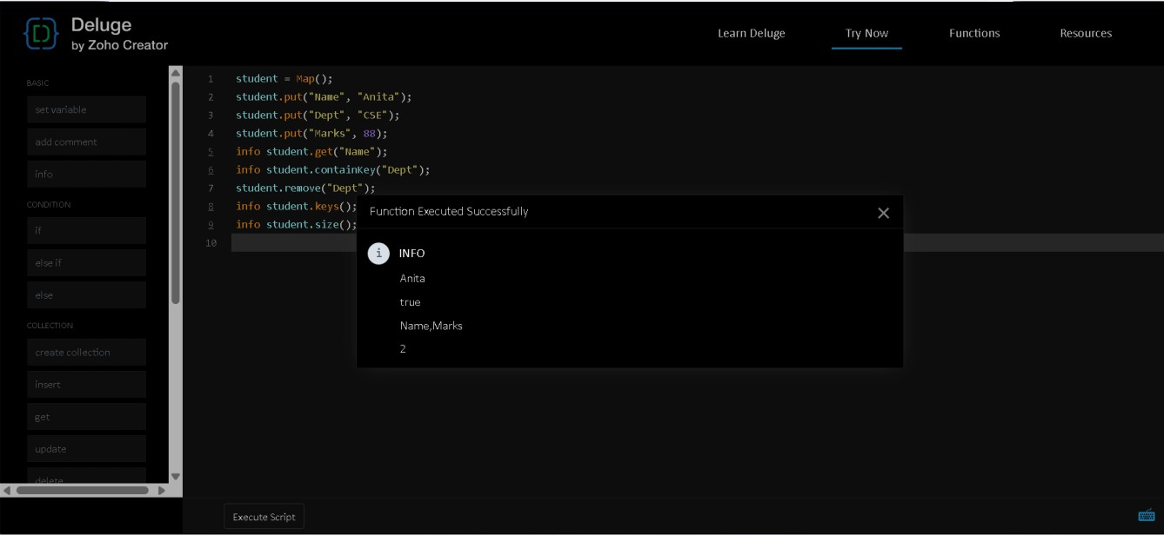
Figure 5: Program 5 (Map operations) and its output

Dept. of Computer Science and Engineering | Rajalakshmi Engineering College

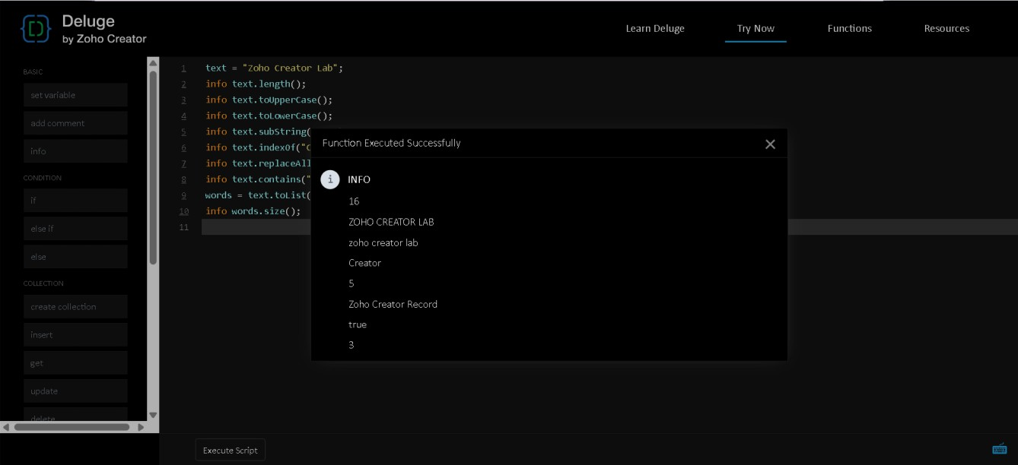
8
Figure 6: Program 6 (String functions) and its output
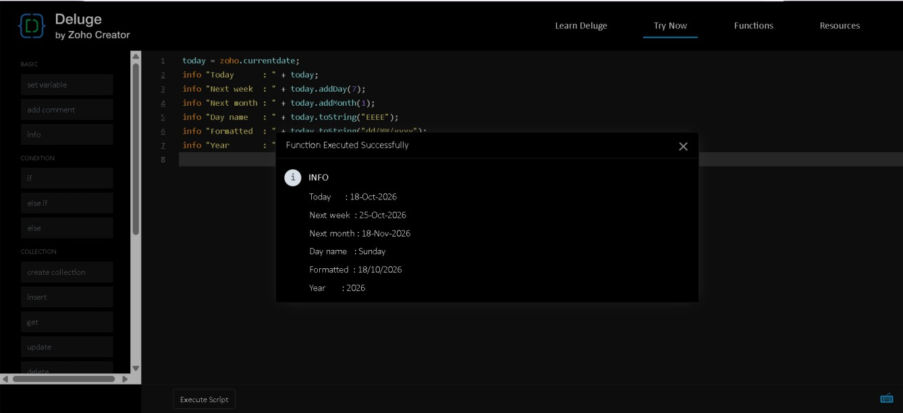
Figure 7: Program 7 (Date functions) and its output

Dept. of Computer Science and Engineering | Rajalakshmi Engineering College

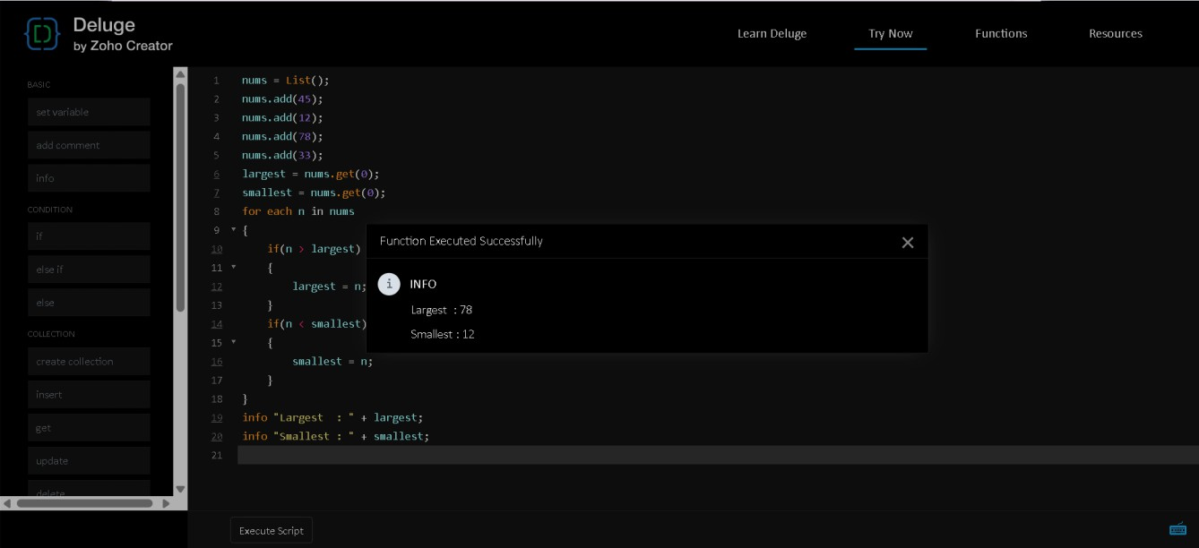
9
Figure 8: Program 8 (Largest and smallest in a list) and its output
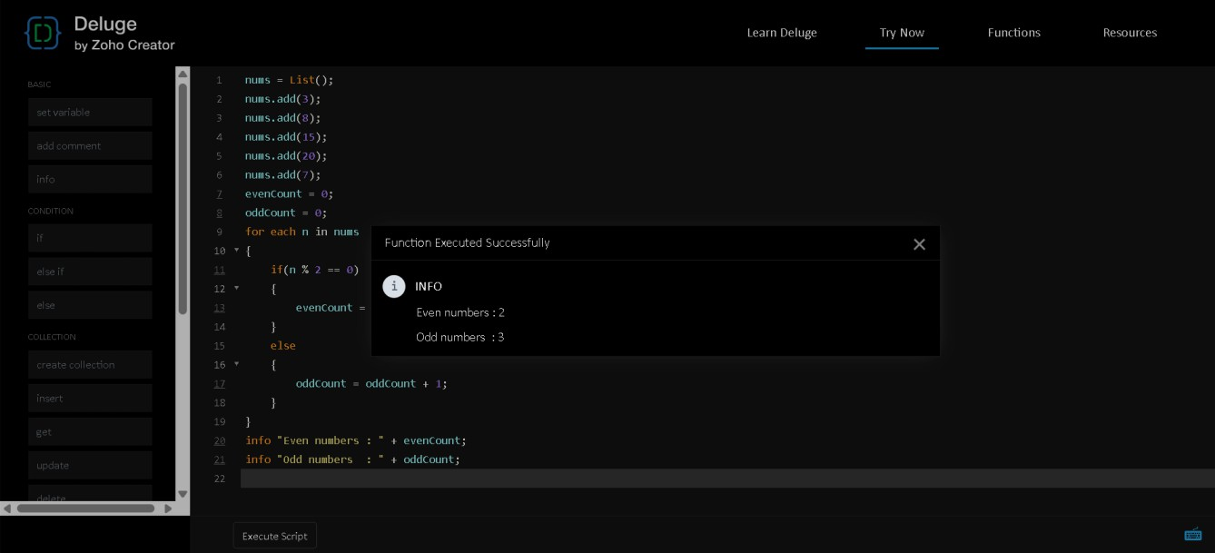
Figure 9: Program 9 (Counting even and odd numbers) and its output

Dept. of Computer Science and Engineering | Rajalakshmi Engineering College

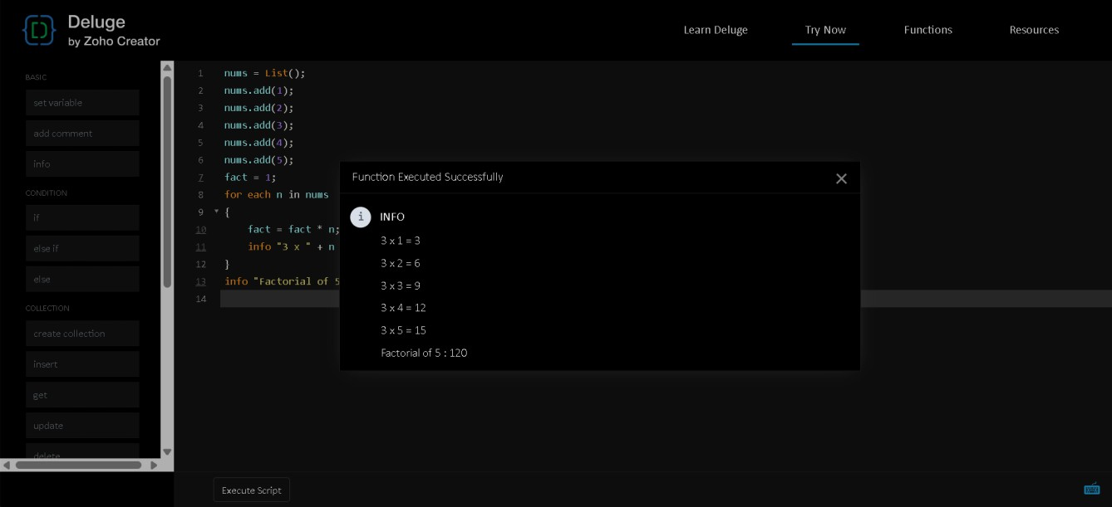
Figure 10: Program 10 (Multiplication table and factorial) and its output

7. Result
Ten standard Deluge programs were written and run in Zoho Creator. They covered variables, conditions, loops, lists, maps, string and date functions, and common number problems. Each script gave the expected output, which shows the basic building blocks used to add logic to any Zoho Creator application.

10 Dept. of Computer Science and Engineering | Rajalakshmi Engineering College

